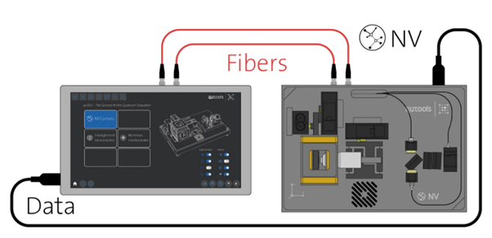
Single Photon Experiment Setup

Experiments on Quantum Key Distribution (QKD)

Quantum State Tomography Experiments

